The Mix and Match Calculator

Team Members: Matt Spurr and Jake Schuenke

|  |  |
| --- | --- |
| **Feature Listing** | **Assigned To** |
| Simple math performed by calculator | Spurr |
| List all plugins found in plugin directory | Spurr |
| Show output in a panel | Spurr |
| Calculator (shows calculation result) | Schuenke |
| Std-out from plugins and calculator | Schuenke |
| GUI updates when new plugin is loaded | Spurr |
| Calculator GUI | Schuenke |

We decided to just load all the plugins at runtime instead of the user selecting them. This was a design decision because the chances of the user ever needing to select what is displayed is small and just displaying everything is fine.

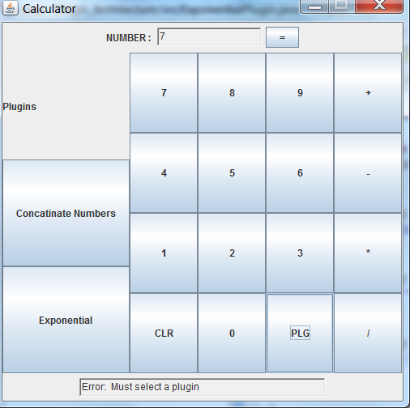

As you can see above, the plugins are displayed to the left of the tool. These are imported synamically from the plugin folder. The GUI on the right included basic operations and clear. The status bar underneath shows any important messages to the user.

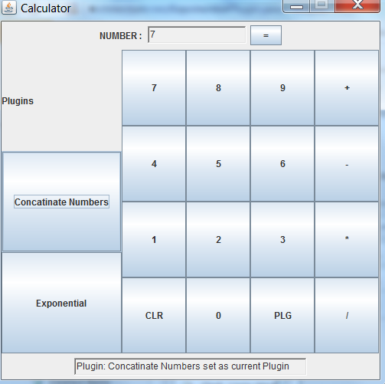

When a plug in is selected, its symbol is displayed above and a message to the status bar is sent with the name of the plugin. The list of plugins loads all available plugins. A plugin can be any two number operation.

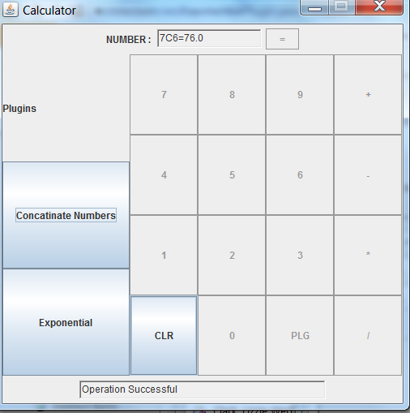

Once any operation, is completed the result is displayed in the window above and a success message is written in the status bar below.